MCB-LEO MEMBERSHIP CERTIFICATE PROGRAM
2017 WINTER CONFERENCE

Institute of Government
Jackson State University

Professional Development Instructional Faculty

_________________________

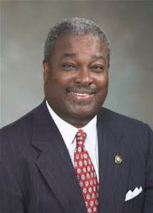

__________________________
Harvey Johnson, Jr., Agreement Coordinator
Former Mayor, City of Jackson

_________________________

_________________________
Gwendolyn Spencer Prater
Dean Emeritus
Jackson State University
College of Public Service

__________________________

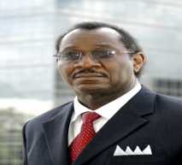
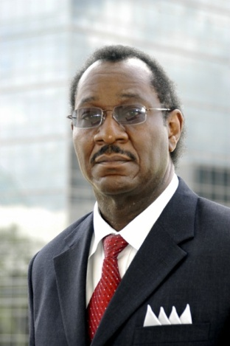

__________________________
Attorney Terry Wallace
Assistant District Attorney,
22nd Circuit Court District
___________________________

___________________________
Ms. Marilyn Hetrick
Human Resource Consultant

